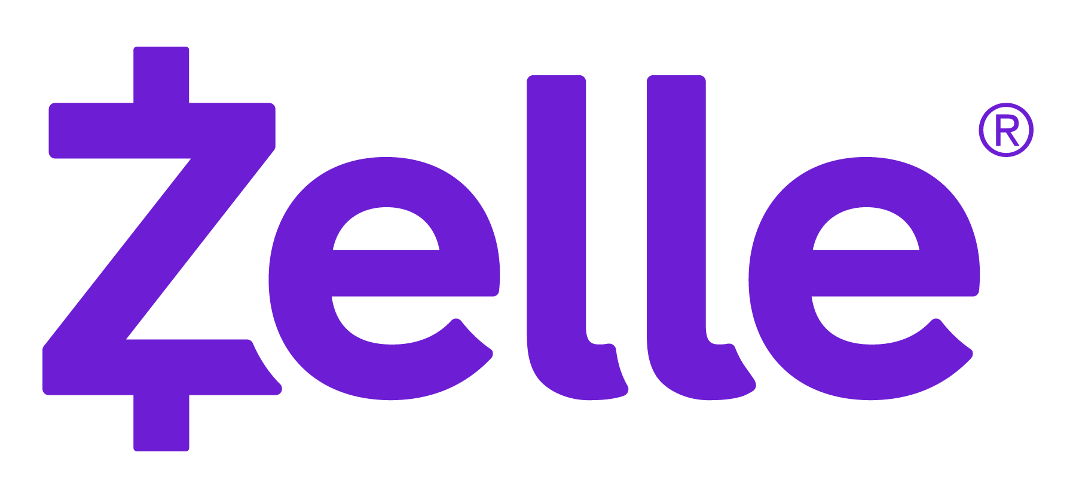

Disbursements FAQs

Corporate to Consumer

**DELETE THIS NOTE BEFORE PUBLISHING**

- Enter your company information into the highlighted sections below.
- After all highlighted areas have been updated, delete this note box.
- Then PDF the document before sharing this information.

UPDATED: JANUARY 2024

- What is Zelle®?
Zelle® is a fast and easy way to receive money directly into your bank account, and it’s offered by banks and credit unions across the U.S. Simply provide [Company Name] with your email address or U.S. mobile number, enroll with Zelle®, and [Company Name] can send your money electronically, regardless of where you bank.¹ With Zelle®, money is sent directly into your bank account, so you don’t have to wait for a check or prepaid card in the mail.

- What are the benefits of receiving my payment with Zelle®?
- Fast – There’s no need to wait for a check or prepaid card to arrive in the mail. Your money will be sent directly into your bank account in minutes.¹
- Safe – Receive money using just an email address or U.S. mobile number. There’s no need to share bank account details.
- Easy – If you’ve never used Zelle®, you can enroll to receive your money in just a few simple steps. If you’re already using Zelle®, simply provide [Company Name] with the email address or U.S. mobile number you used to enroll with Zelle® and you’re done!²

- How do I enroll with Zelle® to receive my money?
Just follow the simple steps below.

Step 1: Provide Us with Your Info
Visit [landing page URL to opt-in to receive electronic payments from Company Name] and select the option to receive your payment from [Company Name] with Zelle®. Provide [Company Name] with the email address or U.S. mobile number you used to enroll with Zelle® so we know where to send your payment.

Note: If you’re already enrolled with Zelle®, you don’t need to do anything else.² You’ll receive an email or text message letting you know your payment will be sent to your bank account. To ensure you receive your money from [Company Name], make sure you provide [Company Name] with the same email address or U.S. mobile number you used to enroll with Zelle®.

Step 2: Enroll with Zelle®
If you’re not yet enrolled with Zelle®, you will receive an email or text notification from [Company to Indicate Email or Text Sender] with instructions on how to complete your enrollment with Zelle®.

- The link included in the email or text notification will take you to enroll.zellepay.com to check if your bank or credit union offers Zelle®.
- Search for your bank or credit union from the list and follow the steps to enroll with Zelle® directly through them.
- If your bank or credit union isn’t listed, no problem! You can still use Zelle® by downloading the Zelle® app for Android or iOS. To enroll with the Zelle® app, enter your basic contact information, an email address or U.S. mobile number, and a debit card.³

*Important note: To ensure you receive your money from [Company Name], make sure you enroll with Zelle® using the same email address or U.S. mobile number you provided to [Company Name].

Step 3: Receive Your Money
When you are enrolled with Zelle®, money goes directly into your bank account and will be available to spend within minutes¹, no need to wait for a check or prepaid card to arrive in the mail.

- When will my payment show up in my bank account?
Once [Company Name] sends your payment with Zelle®, the money will go directly into your enrolled bank account and be available to spend within minutes.¹

- What if my financial institution doesn’t offer Zelle®?
Visit enroll.zellepay.com to see if your bank or credit union offers Zelle®. If your bank or credit union isn’t listed, no problem! You can still use Zelle® by downloading the Zelle® app for Android or iOS. To enroll with the Zelle® app, enter your basic contact information, an email address or U.S. mobile number, and a debit card.³

- Who do I call for help?
Please contact [Company Name’s] customer support team at [XXX-XXX-XXXX].

- Is my information secure?
Keeping your money and information safe is a top priority. When you use Zelle® within your bank or credit union’s mobile app or online banking, your information is protected with the same technology they use to keep your bank account safe.

- Are there any fees to receive my money using Zelle®?
[Company Name] does not charge any fees to receive money with Zelle®. Your mobile carrier’s messaging and data rates may apply.

[NOTE: TO BE MODIFIED BY COMPANY IF FEES ARE APPLICABLE. EARLY WARNING SERVICES, LLC (ZELLE®) DOES NOT DICTATE FEES FOR ANY COMPANY ON ANY TRANSACTIONS].

- What if I accidentally deleted the email or text message telling me to enroll with Zelle®?
Don’t worry! Just visit enroll.zellepay.com and follow the simple steps to enroll with Zelle®.

- How do I find out if I’m already enrolled with Zelle®?
If your bank or credit union offers Zelle®, log into your bank or credit union’s mobile banking app and find Zelle®. Follow the simple steps to enroll your preferred email address or U.S. mobile number. If your email address or U.S. mobile number is already enrolled with a different bank account, you’ll receive an error message. Please call your bank or credit union’s customer support team for assistance.

If your bank or credit union does not offer Zelle®, call Zelle® customer support at 844-428-8542 and they can determine whether you’re already enrolled with Zelle®.

- I’m a small business. Can I receive my payment from [Company Name] with Zelle®?
Some small businesses can receive money from [Company Name] with Zelle®. To determine whether your bank or credit union has enabled small businesses to use Zelle®, log into your mobile banking app and look for Zelle®. If you’re able to enroll with Zelle® using your small business checking account, then you will be able to receive money from [Company Name] with Zelle®. If your bank or credit union does not offer the ability to enroll with Zelle® using your small business checking account, please contact us to discuss an alternative method to receive your payment.

¹ U.S. checking or savings account required to use Zelle®. Transactions sent to enrolled users typically occur in minutes.
² If your bank or credit union doesn’t offer Zelle® and you are already enrolled in the Zelle® app, ask your bank or credit union about your daily transaction limit for your debit card. If the payment you anticipate receiving from us exceeds your daily limit, contact us to discuss other payment options.
³ Visa® or Mastercard® debit card with a U.S. based account (does not include U.S. territories) required. Zelle® does not accept debit cards associated with international deposit accounts or any credit cards.

